PROFORMA INVOICE

Quotation no: B&F PI-302
Date 08/11/2024

To,

B&F Realty-Villa 3
Goa

Dear Sir,
Kindly find the quotation as per your requirement.

ENDO

PROJECT : RIVER GLADE VILLAS | BILL OF QUANTITIES FOR RIVER GLADE VILLAS - Villa 03 | Date: 24 SEPT 2024
Notes : Included are luminaires suggested for - Interior Lighting for VILLA-03
Kindly Refer the detail specifications with this BOQ. If you Find any descripancies , please get it to our notice before placing final order.

Sr No | Specification Description |  |  |  |  | Symbol |  | Manufacturer |  |  | Total Quantity |  | Remarks
1 | LED Strip Light with flat Channel & Clear Cover. |  |  |  |  |  |  | OSRAM LIGHTING
 | Housing: Extruded aluminium Channel & clear Cover. |  |  |  |  | COV1 |  | LFP 1200S-G5-930-10 L1 |  |  | 57.50 |  | The actual Lengths required to be confirmed as per site.
 | Dimension: 17.1 X 8mm |  |  |  |  |  |  | 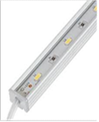 |  |  | Mtrs.
 | Accessory: DG-A002 with Clear Cover
 | Lamp: 11.6W/Mt, 3000K, CRI=90+
 | Lumen Output :1100lm/Mt
 | Control Gear: Remote LED Driver. Dali Dimmable.
 | Power Consumption: 11.6W/Mt
 | IP20
2 | LED Strip Light along circular cove. |  |  |  |  |  |  | OSRAM LIGHTING
 | Housing: 24 V LED strips flexible and cuttable, 50 mm cut unit, with superior optically graded silicone encapsulation. |  |  |  |  | COV1c |  | GFDS600-G1-830-01 |  |  | 14.00 |  | The actual Length required in Circular cove, to be confirmed as per Site.
 | Dimension: 10 X 10mm |  |  |  |  |  |  | 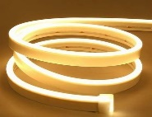 |  |  | Mtrs.
 | Accessory: Fixing clips
 | Lamp: 9W/Mt LED, 110º 3000K, CRI=90+
 | Lumen Output : 620lm/Mt
 | Control Gear: Remote LED Driver. Dali Dimmable.
 | Power Consumption: 9W/Mt
 | IP20
3 | LED Strip light with 45° Channel & Diffuse Cover. |  |  |  |  |  |  | OSRAM LIGHTING
 | Housing: Extruded aluminium Channel & 45° Cover |  |  |  |  | COV2 |  | LFP800S -G5-930-10 L1 |  |  | 104.50 |  | Mounted in wardrobes & Curtain pelmets.  Actual lengths to be confirmed as per site.
 | Dimension: 16 X 16mm |  |  |  |  |  |  |  |  |  | Mtrs.
 | Accessory: DG-A008 with Diffuse Cover
 | Lamp: 8W/Mt LED, 3000K, CRI=90+ |  |  |  |  | 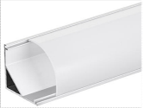
 | Lumen Output : 840 lm/Mt
 | Control Gear: Remote LED Driver. Dali Dimmable.
 | Power Consumption: 8W/Mt
 | IP20
4 | LED Strip Light with Flat Channel & Dotless Diffuse Cover |  |  |  |  |  |  | OSRAM LIGHTING
 | Housing: Extruded aluminium Channel & Diffuse Cover |  |  |  |  | COV3 |  | LFP800S -G5-930-10 L1 |  |  | 67.50 |  | For task Lighting in Kitchen.  Actual lengths to be confirmed as per Site.
 | Dimension:17.1mm X 8mm |  |  |  |  |  |  | 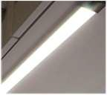 |  |  | Mtrs.
 | Accessory: DG-A002 with Diffuse Cover
 | Lamp: 8W/Mt LED, 3000K, CRI=90+
 | Lumen Output :840lm/Mt
 | Control Gear: Remote LED Driver. Dali Dimmable.
 | Power Consumption: 8W/Mt
 | IP65
5 | LED Strip Light with Channel & Dotless Diffuse Cover |  |  |  |  |  |  | OSRAM LIGHTING
 | Housing: Extruded aluminium Channel & Diffuse Cover |  |  |  |  | COV4 |  | LF500-G1-930-10 L2 |  |  | 128.50 |  | Actual Length to be confirmed as per site.
 | Dimension: 17.1mm X 8mm |  |  |  |  |  |  | 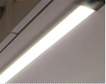 |  |  | Mtrs.
 | Accessory: DG-A010 with Diffuse Cover
 | Lamp: 3.9W/Mt LED, 3000K, CRI=90+
 | Lumen Output : 400lm/Mt
 | Control Gear: Remote LED Driver. Dali Dimmable.
 | Power Consumption: 3.9W
 | IP65
6 | Flex Light with Top View |  |  |  |  |  |  | OSRAM LIGHTING
 | Housing: Silicone |  |  |  |  | FLX1 |  | GFDT400-G1-830-01 |  |  | 9.20 |  | Actual Length to be confirmed as per site.
 | Dimension: 10mm X 10mm |  |  |  |  |  |  | 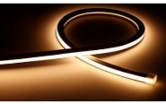 |  |  | Mtrs.
 | Accessory: Mounting Clips.
 | Lamp: 6W/Mts LED ,110° CRI=90+
 | Lumen Output : 420lm/Mts
 | Control Gear: Remote LED Driver. Dali Dimmable.
 | Power Consumption: 6W/Mts
 | IP65
7 | Ceiling Recessed LED Down Light (IP Rated) |  |  |  |  |  |  | ENDO LIGHTING
 | Housing: Die cast Aluminium |  |  |  |  | IPR1 |  | GERD8901W-T |  |  | 33.00
 | Dimension:Trim∅=60mm, Ht=95mm |  |  |  |  | White Trim |  | 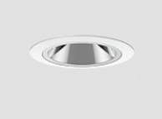 |  |  | Nos
 | Lamp:10.2W LED, 22° Fixed,3000K, CRI=90+(R9≥40+)
 | Lumen Output : 446lm
 | Control Gear: Remote LED Driver. Dali Dimmable.
 | Power Consumption: 10.2W
 | IP44
8 | In-ground LED Up lighter. |  |  |  |  |  |  | PUK LIGHTING
 | Housing: Aluminium Body & Stainless Steel Trim |  |  |  |  | IUL1 |  | 201073 |  |  | 15.00
 | Dimension: Trim∅=81mm, & Ht=85mm |  |  |  |  |  |  | 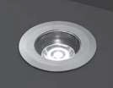 |  |  | Nos
 | Lamp: 5W LED, 10°, 3000K CRI=80+
 | Lumen Output : 489lm
 | Control Gear: Remote LED Driver. Non-Dimmable.
 | Power Consumption: 5W
 | IP68
9 | Profile System , Recessed Magnetic Track. |  |  |  |  |  |  | DELTA LIGHTING |  |  |  |  | Drawing to be shared with Vendor to finalize unit modules & connectors.
 | Housing: Anodised Aluminum |  |  |  |  | PSY1 |  | Splitline M20 |  |  | 12.00
 | Dimensionin Section : W=53mm, D=50mm |  |  |  |  |  |  | 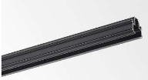 |  |  | Mtrs.
 | Accessory: Connector Sets - As per Vendor. |  |  |  |  |  |  |  |  |  | LEngth
 | Control Gear: Remote LED Driver. Dali Dimmable.
 | IP20
9a | Recessed Linear LED light in Profile System. |  |  |  |  |  |  | DELTA LIGHTING
 | Housing: Anodised Aluminum |  |  |  |  | M1 |  | LND-06-SP-30F-B-M-MDL (23303 9000) |  |  | 8.00
 | Dimension: L=621mm W=20mm, D=50mm |  |  |  |  |  |  |  |  |  | Nos
 | Accessory: SplitLine M20 - Profile |  |  |  |  |  |  | 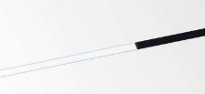
 | Lamp: 9.1W/621mm LED, 3000K, CRI=90+(R9≥40+)
 | Lumen Output : 625lm/621mm
 | Control Gear: Remote LED Driver. Dali Dimmable.
 | Power Consumption: 9.1W
 | IP20
9b | Recessed LED Twin Spot light in Profile System. |  |  |  |  |  |  | DELTA LIGHTING
 | Housing: Anodised Aluminum |  |  |  |  | M2 |  | B (233179320) |  |  | 12.00
 | Dimension: TrimØ=39mm, L=170mm H=116mm |  |  |  |  |  |  |  |  |  | Nos
 | Accessory: SplitLine M20 - Profile |  |  |  |  |  |  | 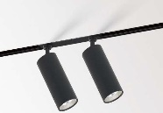
 | Lamp: 2X8.5W LED, 3000K, CRI=90+(R9≥40+)
 | Lumen Output : 1089lm
 | Control Gear: Remote LED Driver. Dali Dimmable.
 | Power Consumption: 2X8.5W
 | IP20
10 | Ceiling Recessed LED Pin Spot Down Light. |  |  |  |  |  |  | ENDO LIGHTING
 | Housing: Die cast aluminium |  |  |  |  | PNS1 |  | GERD9898W-T |  |  | 5.00
 | Dimension: Trim∅=37mm, CutOut∅=35mm Ht=42mm. |  |  |  |  |  |  | 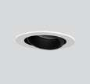 |  |  | Nos
 | Lamp: 3.1W LED 29°, Focusable, 3000K, CRI=93+(R9≥40+)
 | Lumen Output: 178lm
 | Control Gear: Remote LED Driver. Dali Dimmable.
 | Power Cosumption: 3.1W
 | IP20
11 | Ceiling Recessed LED Pin Spot Down Light. |  |  |  |  |  |  | ENDO LIGHTING
 | Housing: Die cast aluminium |  |  |  |  | PNS2 |  | GERD9869W-T |  |  | 8.00
 | Dimension: Trim∅=60mm,Cut Out∅=50mm Ht=101mm. |  |  |  |  |  |  | 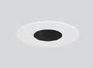 |  |  | Nos
 | Lamp: 10.3W LED 21°, Focusable, 3000K, CRI=93+(R9≥40+)
 | Lumen Output: 446lm
 | Control Gear: Remote LED Driver. Dali Dimmable.
 | Power Cosumption: 10.3W
 | IP20
12 | Ceiling Recessed LED Down Light. |  |  |  |  |  |  | ENDO LIGHTING
 | Housing: Die cast aluminium |  |  |  |  | RDN1 |  | GERD8280WB-T |  |  | 37.00
 | Dimension:∅=85mm, H=135mm. |  |  |  |  |  |  | 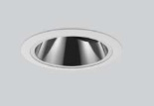 |  |  | Nos
 | Lamp: 19.6W LED 20°, Focusable, 3000K, CRI=93+(R9≥40+)
 | Lumen Output: 807lm
 | Control Gear: Remote LED Driver. Dali Dimmable.
 | Power Cosumption: 19.8W
 | IP20
13 | Ceiling Reccesed LED Down Light. |  |  |  |  |  |  | ENDO Lighting
 | Housing: Die cast aluminium |  |  |  |  | RDN2 |  | GERD8282WB-T |  |  | 23.00
 | Dimension:L=∅=85mm, H=135mm. |  |  |  |  |  |  | 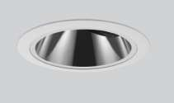 |  |  | Nos
 | Lamp: 19.6W LED 33°, Focusable, 3000K, CRI=93+(R9≥40+)
 | Lumen Output : 1116lm
 | Control Gear: Remote LED Driver. Dali Dimmable.
 | Power Consumption: 19.8W
 | IP20
14 | Ceiling Reccesed LED Twin Down Light.(Black Trim Required) |  |  |  |  |  |  | ENDO Lighting
 | Housing: Die cast aluminium |  |  |  |  | RDN3 |  | GERD8849W-T |  |  | 32.00 |  | Black Trim Finish (I.D to confirm)
 | Dimension: o 122 X65mm & H=115mm |  |  |  |  |  |  | 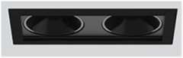 |  |  | Nos
 | Lamp:14.2W LED, 26°, Focusable, 3000K, CRI=93+(R9≥40+)
 | Lumen Output : 1254lm
 | Control Gear: Remote LED Driver. Dali Dimmable.
 | Power Consumption: 14.2W/Unit
 | IP20
15 | Ceiling Recessed LED Down Light |  |  |  |  |  |  | ENDO Lighting
 | Housing: Die cast aluminium |  |  |  |  | RDN4b |  | GERD8127WA-T |  |  | 15.00 |  | Black Trim Finish (In Bedroom 04 sloping ceiling)
 | Dimension: ∅=108mm, Depth=100mm. |  |  |  |  |  |  | 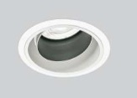 |  |  | Nos
 | Lamp: 19.8W LED,19°, Focusable ,3000K CRI=96+(R9≥40+)
 | Lumen Output : 1377lm
 | Control Gear: Remote LED Driver. Dali Dimmable.
 | Power Consumption: 19.8W
 | IP20
16 | Ceiling Recessed LED Down Light |  |  |  |  |  |  | ENDO Lighting
 | Housing: Die cast aluminium |  |  |  |  | RDN4w |  | GERD8127WA-T |  |  | 12.00 |  | White Trim Finish (In Terrace Lobby sloping ceiling)
 | Dimension: ∅=108mm, Depth=100mm. |  |  |  |  |  |  |  |  |  | Nos
 | Lamp: 19.8W LED,19° , Focusable ,3000K CRI=96+(R9≥40+)
 | Lumen Output : 1377lm
 | Control Gear: Remote LED Driver. Dali Dimmable.
 | Power Consumption: 19.8W
 | IP20
17 | Ceiling Recessed LED Down Light |  |  |  |  |  |  | ENDO Lighting
 | Housing: Die cast aluminium |  |  |  |  | RDN5 |  | GERD8202WB-T |  |  | 5.00
 | Dimension: ∅=108mm, Depth=133mm. |  |  |  |  |  |  |  |  |  | Nos
 | Lamp: 28.5W LED, 32°, Fixed Optics, 3000K CRI=83+(R9≥40+)
 | Lumen Output : 1597lm
 | Control Gear: Remote LED Driver. Dali Dimmable.
 | Power Consumption: 28.5W
 | IP20
18 | Surface Mounted LED Down Light. |  |  |  |  |  |  | ABBY Lighting
 | Housing: Die cast aluminium |  |  |  |  | SDN1 |  | iPlane round surface-15W |  |  | 14.00
 | Dimension: ∅=152mm & H=38mm. |  |  |  |  |  |  | 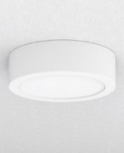 |  |  | Nos
 | Lamp: 15W LED, 116°, Fixed, 3000K, CRI=96+(R9≥40+)
 | Lumen Output : 1209lm
 | Control Gear: Integral LED Driver. Dali Dimmable.
 | Power Consumption: 15W
 | IP44 Required
19 | Ceiling Recessed LED Light, Fixed. |  |  |  |  |  |  | ABBY Lighting
 | Housing: Spun Aluminium |  |  |  |  | SDN2 |  | SPA 63 - 22W |  |  | 12.00
 | Dimension: ∅=94mm, Cutout∅=84 & Height=104mm. |  |  |  |  |  |  | 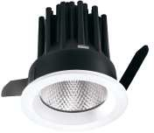 |  |  | Nos
 | Lamp: 22W LED, 32° Fixed, 3000K, CRI=90+(R9≥40+)
 | Lumen Output : 1704 lm
 | Control Gear: Remote LED Driver. Dali Dimmable.
 | Power Consumption: 22W
 | minimum IP44 Required.
20 | Spike Mounted LED Projector Light. |  |  |  |  |  |  | PUK Lighting
 | Housing: Hard Anodized Aluminium |  |  |  |  | SPK1 |  | 101903 |  |  | 11.00
 | Accessories : Anti-glare snoot (AC098)& Spike (AC044) |  |  |  |  |  |  | 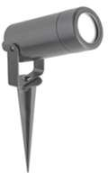 |  |  | Nos
 | Dimension: ∅=50mm, Ht=90mm
 | Lamp: 10W LED,10º, 3000K CRI=80+
 | Lumen Output : 489lm
 | Control Gear: Remote LED Driver. Non-Dimmable.
 | Power Consumption: 10W
21 | Spike Mounted LED Projector Light. |  |  |  |  |  |  | PUK Lighting
 | Housing: Hard Anodized Aluminium |  |  |  |  | SPK2 |  | 101901 |  |  | 11.00
 | Accessory: Anti-glare snoot (AC098) & Ground Burried Spike (AC044) |  |  |  |  |  |  | 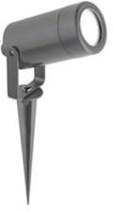 |  |  | Nos
 | Dimension: ∅=35mm, Ht=63mm
 | Lamp: 3W LED, 45º, 3000K CRI=80+
 | Lumen Output : 230lm
 | Control Gear: Remote LED Driver. Non-Dimmable.
 | Power Consumption: 3W
 | IP66
22 | Underwater LED Up Lighter. |  |  |  |  |  |  | PUK Lighting
 | Housing: Stainless Steel |  |  |  |  | UWL3 |  | 301004 |  |  | 2.00 |  | Black Finish Required
 | Dimension: TrimØ=81mm, Cut OutØ=79mm & Ht=100mm. |  |  |  |  |  |  | 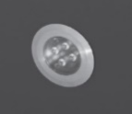 |  |  | Nos
 | Lamp: 6W LED, 10°, 3000K, CRI=80+
 | Lumen Output : 576lm
 | Control Gear: Remote LED Driver. Dali Dimmable.
 | Power Consumption: 6W
 | IP68
23 | Wall Mounted LED Light. |  |  |  |  |  |  | PUK Lighting
 | Housing: Die cast Aluminium |  |  |  |  | WML1 |  | 402403 |  |  | 5.00
 | Dimension: L=354mm, W=120mm & Ht=36mm. |  |  |  |  |  |  | 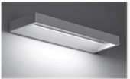 |  |  | Nos
 | Lamp: 12W LED, 3000K, CRI=80+
 | Lumen Output : 574lm
 | Control Gear: Integral LED Driver. Dali Dimmable.
 | Power Consumption: 12W
 | IP65
24 | Wall Recessed LED Light. |  |  |  |  |  |  | PUK Lighting
 | Housing: Die cast Aluminium |  |  |  |  | WRL1 |  | 502017 |  |  | 11.00
 | Dimension: Trim Size=255 X 76mm, Depth= 81mm |  |  |  |  |  |  | 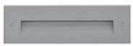 |  |  | Nos
 | Lamp: 7W LED, 120°, 3000K, CRI=80+
 | Lumen Output : 180lm
 | Control Gear: Integral LED Driver. Non- Dimmable.
 | Power Consumption: 7W
 | IP65
25 | Wall Recessed LED FootLight. |  |  |  |  |  |  | PUK Lighting
 | Housing: Stainless Steel |  |  |  |  | WRL2 |  | 502015 |  |  | 21.00
 | Dimension: Trim Size=79 X 79mm, Depth= 77mm |  |  |  |  |  |  | 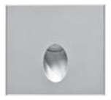 |  |  | Nos
 | Lamp: 1W LED, 3000K, CRI=80+
 | Lumen Output : 60lm
 | Control Gear: Integral LED Driver. Non- Dimmable.
 | Power Consumption: 1W
 | IP65
26 | Wall Recessed LED Light (To be Customize to 4W). |  |  |  |  |  |  | PUK Lighting
 | Housing: Die cast Aluminium |  |  |  |  | WRL3 |  | 502017 |  |  | 6.00
 | Dimension: Trim Size=255 X 76mm, Depth= 81mm |  |  |  |  |  |  |  |  |  | Nos
 | Lamp: 4W LED, 120°, 3000K, CRI=80+
 | Lumen Output : 100lm
 | Control Gear: Integral LED Driver. Non- Dimmable.
 | Power Consumption: 4W
 | IP65

DATE: 07 NOV 2024
 |  | ENDO ALTERNATES
 |  | Sr No | Specification Description | Symbol | Manufacturer | Total Quantity | Remarks/ L@W Comments | BEST PRICE | Total
 |  | 1 | LED Strip Light with flat Channel & Clear Cover. |  | ENDO LIGHTING
 |  |  | Housing: Extruded aluminium Channel & clear Cover. | COV1 | TSUKI-R-1714-10W/Mtr | 57.50 | SUGGEST IN 10W/Mt.  The actual Lengths required to be confirmed as per site., OLD QTY 55 MTR | 1172 | 67390
 |  |  | Dimension: 17 X 14mm |  | 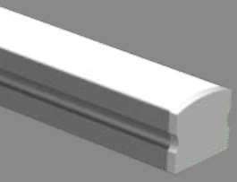 | Mtrs. |  | 1172 | 67390
 |  |  | Accessory: Channel & Clear Cover. |  |  |  |  | 1172 | 67390
 |  |  | Lamp: 15W/Mt, 3000K, CRI=90+ |  |  |  |  | 1172 | 67390
 |  |  | Lumen Output :1500lm/Mt |  |  |  |  | 1172 | 67390
 |  |  | Control Gear: Remote LED Driver. Dali Dimmable. |  |  |  |  | 1172 | 67390
 |  |  | Power Consumption: 10W/Mt |  |  |  |  | 1172 | 67390
 |  |  | IP20 |  |  |  |  | 1172 | 67390
 |  |  |  |  | 80W, 24V Dali Driver | 12.00 |  | 4992 | 59904
 |  | 2 | LED Strip Light along circular cove. |  | ENDO LIGHTING |  |  | 4425 | 61950
 |  |  | Housing: Silicone | COV1c | TSUKI-NF-DB-16X16-NS-130- 14W-IP67 | 14.00 | OK.  The actual Length required in Circular cove, to be confirmed as per Site. | 4425 | 61950
 |  |  | Dimension: 16 X 16mm |  | 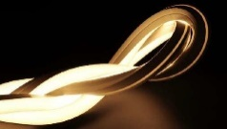 | Mtrs. |  | 4425 | 61950
 |  |  | Accessory: Fixing Clips |  |  |  |  | 4425 | 61950
 |  |  | Lamp: 14W/Mt LED, 120° 3000K, CRI=85+ |  |  |  |  | 4425 | 61950
 |  |  | Lumen Output : 710lm/Mt |  |  |  |  | 4425 | 61950
 |  |  | Control Gear: Remote LED Driver. Dali Dimmable. |  |  |  |  | 4425 | 61950
 |  |  | Power Consumption: 14W/Mt |  |  |  |  | 4425 | 61950
 |  |  | IP67 |  |  |  |  | 4425 | 61950
 |  |  |  |  | 80W, 24V Dali Driver | 3.00 |  | 4992 | 14976
 |  |  |  |  |  | Nos |  | 4992 | 14976
 |  | 3 | LED Strip light with 45° Channel & Diffuse Cover. |  | ENDO LIGHTING |  |  | 1319 | 137836
 |  |  | Housing: Extruded aluminium 45° Channel & Diffuse Cover | COV2 | TSUKI-R-1818-10W/Mtr | 104.50 | OK.  Mounted in wardrobes & Curtain pelmets.  Actual lengths to be confirmed as per site. OLD QTY 88 MTR | 1319 | 137836
 |  |  | Dimension: 18 X18mm |  | 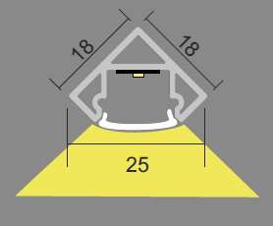 | Mtrs. |  | 1319 | 137836
 |  |  | Accessory: 45° Channel with Diffuse Cover |  |  |  |  | 1319 | 137836
 |  |  | Lamp: 10W/Mt LED, 3000K, CRI=90+ |  |  |  |  | 1319 | 137836
 |  |  | Lumen Output : 1000lm/Mt |  |  |  |  | 1319 | 137836
 |  |  | Control Gear: Remote LED Driver. Dali Dimmable. |  |  |  |  | 1319 | 137836
 |  |  | Power Consumption: 10W/Mt |  |  |  |  | 1319 | 137836
 |  |  | IP20 |  |  |  |  | 1319 | 137836
 |  |  |  |  | 80W, 24V Dali Driver | 21.00 |  | 4992 | 104832
 |  | 4 | LED Strip Light with Flat Channel & Dotless Diffuse Cover |  | ENDO LIGHTING |  |  | 1172 | 79110
 |  |  | Housing: Extruded aluminium Channel & Diffuse Cover | COV3 | TSUKI-R-1714-10W/Mtr | 67.50 | OK.  For task Lighting in Kitchen.  Actual lengths to be confirmed as per Site., OLD QTY 62 MTR | 1172 | 79110
 |  |  | Dimension: 17 X 14mm |  |  | Mtrs. |  | 1172 | 79110
 |  |  | Accessory: Channel with Diffuse Cover |  |  |  |  | 1172 | 79110
 |  |  | Lamp: 10W/Mt LED, 3000K, CRI=90+ |  |  |  |  | 1172 | 79110
 |  |  | Lumen Output :100lm/Mt |  |  |  |  | 1172 | 79110
 |  |  | Control Gear: Remote LED Driver. Dali Dimmable. |  |  |  |  | 1172 | 79110
 |  |  | Power Consumption: 10W/Mt |  |  |  |  | 1172 | 79110
 |  |  | IP20 |  |  |  |  | 1172 | 79110
 |  |  |  |  | 80W, 24V Dali Driver | 14.00 |  | 4992 | 69888
 |  | 5 | LED Strip Light with Channel & Dotless Diffuse Cover |  | ENDO LIGHTING |  |  | 1251 | 160754
 |  |  | Housing: Extruded aluminium Channel & Cover | COV4 | TSUKI-S-1714-5W/Mtr (IP65) | 128.50 | IP65 Required  Actual Length to be confirmed as per site., OLD QTY 125 MTR & IP20 | 1251 | 160754
 |  |  | Dimension: 17mm X 14mm |  |  | Mtrs. |  | 1251 | 160754
 |  |  | Accessory: Channel with Diffuse Cover |  |  |  |  | 1251 | 160754
 |  |  | Lamp: 5W/Mt LED, 3000K, CRI=90+ |  |  |  |  | 1251 | 160754
 |  |  | Lumen Output : 500lm/Mt |  |  |  |  | 1251 | 160754
 |  |  | Control Gear: Remote LED Driver. Dali Dimmable. |  |  |  |  | 1251 | 160754
 |  |  | Power Consumption: 5W |  |  |  |  | 1251 | 160754
 |  |  | IP65 |  |  |  |  | 1251 | 160754
 |  |  |  |  | 80W, 24V Dali Driver | 14.00 |  | 4992 | 69888
 |  | 6 | Flex Light with Top View |  | ENDO LIGHTING |  |  | 4425 | 40710
 |  |  | Housing: Silicone | FLX1 | TSUKI-NF-DB-16X16-NS-130- 9W-IP67 | 9.20 | 14W/Mt is too high, (5W/Mt to 7W/Mt LED required)  Actual Length to be confirmed as per site., OLD QTY 3.15 MTR | 4425 | 40710
 |  |  | Dimension: 16 X 16mm |  | TSUKI-NF-DB-16X16-NS-130- 9W-IP67 | Mtrs. |  | 4425 | 40710
 |  |  | Accessory: Fixing Clips |  |  |  |  | 4425 | 40710
 |  |  | Lamp: 9W/Mt LED, 120° 3000K, CRI=85+ |  |  |  |  | 4425 | 40710
 |  |  | Lumen Output : 710lm/Mt |  |  |  |  | 4425 | 40710
 |  |  | Control Gear: Remote LED Driver. Dali Dimmable. |  |  |  |  | 4425 | 40710
 |  |  | Power Consumption: 9W/Mt |  |  |  |  | 4425 | 40710
 |  |  | IP67 |  |  |  |  | 4425 | 40710
 |  |  |  |  | 80W, 24V Dali Driver | 2.00 |  | 4992 | 9984
 |  |  |  |  |  |  | OLD QTY 32 NOS | 9045 | 298485
 |  | 7 | Ceiling Recessed LED Down Light (IP Rated) |  | ENDO LIGHTING |  | OLD QTY 32 NOS | 9045 | 298485
 |  |  | Housing: Die cast Aluminium | IPR1 | GERD8901W-T | 33.00 | OLD QTY 32 NOS | 9045 | 298485
 |  |  | Dimension:Trim∅=60mm, Ht=95mm | White Trim |  | Nos | OLD QTY 32 NOS | 9045 | 298485
 |  |  | Lamp: 10.2W LED, 23° Fixed,3000K, CRI=90+(R9≥40+) | White Trim |  |  | OLD QTY 32 NOS | 9045 | 298485
 |  |  | Lumen Output : 446lm |  |  |  | OLD QTY 32 NOS | 9045 | 298485
 |  |  | Control Gear: Remote LED Driver. Dali Dimmable. |  |  |  | OLD QTY 32 NOS | 9045 | 298485
 |  |  | Power Consumption: 10.2W |  |  |  | OLD QTY 32 NOS | 9045 | 298485
 |  |  | IP44 |  |  |  | OLD QTY 32 NOS | 9045 | 298485
 |  | 8 | In-ground LED Up lighter. |  |  |  |  | 9317 | 139755
 |  |  |  | IUL1 | ELUIR1-70-0630-KN | 15.00 | Share the data sheet of this. | 9317 | 139755
 |  |  | ELUIR1-70-0630-KN  (Tsuki ingorund 5.8W, 9Deg, 3000K, 80 CRI, 70mm Dia, Non Dimmable ) |  | 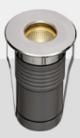 | Nos | Share the data sheet of this. | 9317 | 139755
 |  | 9 | Profile System , Recessed Magnetic Track. |  |  |  |  | 5842 | 70104
 |  |  | XR-CMT410 (48V DC Recess track with all accesoried) | PSY1 | Track | 12.00 | A recessed track with  trim preferred.  Share the data sheet of this.  Drawing to be shared with Vendor to finalize unit modules & connectors. | 5842 | 70104
 |  |  | XR-CMT410 (48V DC Recess track with all accesoried) |  | 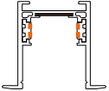 | Nos |  | 5842 | 70104
 |  | 9a | Recessed Linear LED light in Profile System. |  | ENDO LIGHTING |  |  | 12491 | 112419
 |  |  | Housing: Aluminum + PC | M1 | FL-24G | 9.00 | Quantity will change since length is lesser. Refer the shared render given by I.D.  Share the IES file to evaluate. | 12491 | 112419
 |  |  | Dimension: L=485mm W=25mm, D=46mm |  | FL-24G | Nos |  | 12491 | 112419
 |  |  | Accessory: Recessing Track - Profile |  | 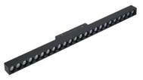 |  |  | 12491 | 112419
 |  |  | Lamp: 24W/485mm LED, 3000K, CRI=90+(R9≥40+) |  |  |  |  | 12491 | 112419
 |  |  | Lumen Output : 1000lm/300mm |  |  |  |  | 12491 | 112419
 |  |  | Control Gear: Remote LED Driver. Dali Dimmable. |  |  |  |  | 12491 | 112419
 |  |  | Power Consumption:24W/485mm |  |  |  |  | 12491 | 112419
 |  |  | IP20 |  |  |  |  | 12491 | 112419
 |  | 9b | Recessed LED Twin Spot light in Profile System. |  | ENDO LIGHTING |  |  | 14514 | 174168
 |  |  | Housing: Aluminum | M2 | GERS7013BA-T(Mini 40 spot) | 12.00 | Quantity will change. Refer the shared render given by I.D.  Share the IES file to evaluate. | 14514 | 174168
 |  |  | Dimension: TrimØ=45mm, L=94mm & Ht=52mm |  | 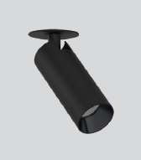 | Nos |  | 14514 | 174168
 |  |  | Accessory: Recessing Track - Profile |  |  |  |  | 14514 | 174168
 |  |  | Lamp: 10.2W LED 33°, 3000K, CRI=83+(R9≥40+) |  |  |  |  | 14514 | 174168
 |  |  | Lumen Output : 767lm |  |  |  |  | 14514 | 174168
 |  |  | Control Gear: Remote LED Driver. Dali Dimmable. |  |  |  |  | 14514 | 174168
 |  |  | Power Consumption: 10.2W |  |  |  |  | 14514 | 174168
 |  |  | IP20 |  |  |  |  | 14514 | 174168
 |  | 10 | Ceiling Recessed LED Pin Spot Down Light. |  | GERD9898W-T |  |  | 5686 | 28430
 |  |  | Housing: Die cast aluminium | PNS1 |  | 5.00 | The alternate is missing in received BOQ, NEW ITEM | 5686 | 28430
 |  |  | Dimension: Trim∅=37mm, CutOut∅=35mm Ht=42mm. |  |  | Nos | The alternate is missing in received BOQ, NEW ITEM | 5686 | 28430
 |  |  | Lamp: 3.1W LED 29°, Focusable, 3000K, CRI=93+(R9≥40+) |  |  |  | The alternate is missing in received BOQ, NEW ITEM | 5686 | 28430
 |  |  | Lumen Output: 178lm |  |  |  | The alternate is missing in received BOQ, NEW ITEM | 5686 | 28430
 |  |  | Control Gear: Remote LED Driver. Dali Dimmable. |  |  |  | The alternate is missing in received BOQ, NEW ITEM | 5686 | 28430
 |  |  | Power Cosumption: 3.1W |  |  |  | The alternate is missing in received BOQ, NEW ITEM | 5686 | 28430
 |  |  | IP20 |  |  |  | The alternate is missing in received BOQ, NEW ITEM | 5686 | 28430
 |  | 11 | Ceiling Recessed LED Pin Spot Down Light. |  |  |  |  | 10552 | 84416
 |  |  | Housing: Die cast aluminium | PNS2 | GERD9869W-T | 8.00 | The alternate is missing in received BOQ, NEW ITEM | 10552 | 84416
 |  |  | Dimension: Trim∅=60mm,Cut Out∅=50mm Ht=101mm. |  |  | Nos | The alternate is missing in received BOQ, NEW ITEM | 10552 | 84416
 |  |  | Lamp: 10.3W LED 21°, Focusable, 3000K, CRI=93+(R9≥40+) |  |  |  | The alternate is missing in received BOQ, NEW ITEM | 10552 | 84416
 |  |  | Lumen Output: 446lm |  |  |  | The alternate is missing in received BOQ, NEW ITEM | 10552 | 84416
 |  |  | Control Gear: Remote LED Driver. Dali Dimmable. |  |  |  | The alternate is missing in received BOQ, NEW ITEM | 10552 | 84416
 |  |  | Power Cosumption: 10.3W |  |  |  | The alternate is missing in received BOQ, NEW ITEM | 10552 | 84416
 |  |  | IP20 |  |  |  | The alternate is missing in received BOQ, NEW ITEM | 10552 | 84416
 |  | 12 | Ceiling Recessed LED Down Light. |  | ENDO LIGHTING |  |  | 9621 | 355977
 |  |  | Housing: Aluminium | RDN1 | GSTDA1800W-AMH30 | 37.00 | Kindly Suggest ACCORD (2000 TYPE -  19.6W Middle Beam Angle), OLD QTY 32 NOS | 9621 | 355977
 |  |  | Dimension:∅=65mm, H=129mm. |  | 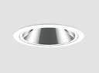 | Nos |  | 9621 | 355977
 |  |  | Lamp: 19.8W LED 23°, Focusable, 3000K, CRI=93+(R9≥40+) |  |  |  |  | 9621 | 355977
 |  |  | Lumen Output: 1243lm |  |  |  |  | 9621 | 355977
 |  |  | Control Gear: Remote LED Driver. Dali Dimmable. |  |  |  |  | 9621 | 355977
 |  |  | Power Cosumption: 19.8W |  |  |  |  | 9621 | 355977
 |  |  | IP20 |  |  |  |  | 9621 | 355977
 |  | 13 | Ceiling Reccesed LED Down Light. |  | ENDO LIGHTING |  |  | 9621 | 221283
 |  |  | Housing: Aluminium | RDN2 | GSTDA1800W-AWH30 | 23.00 | Kindly Suggest ACCORD (2000 TYPE -  19.6W Wide Beam Angle), OLD QTY 32 NOS | 9621 | 221283
 |  |  | Dimension:L=∅=65mm, H=129m. |  | 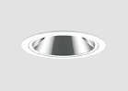 | Nos |  | 9621 | 221283
 |  |  | Lamp: 19.8W LED 33°, Focusable, 3000K, CRI=93+(R9≥40+) |  |  |  |  | 9621 | 221283
 |  |  | Lumen Output: 1368lm |  |  |  |  | 9621 | 221283
 |  |  | Control Gear: Remote LED Driver. Dali Dimmable. |  |  |  |  | 9621 | 221283
 |  |  | Power Cosumption: 19.8W |  |  |  |  | 9621 | 221283
 |  |  | IP20 |  |  |  |  | 9621 | 221283
 |  | 14 | Ceiling Reccesed LED Twin Down Light.  (Black Trim Required) |  |  |  |  | 17792 | 569344
 |  |  | Housing: Die cast aluminium ( Cust to Black Trim ) | RDN3 | GERD8849W-T | 32.00 | Black Trim Finish (I.D to confirm)  This is OK. | 17792 | 569344
 |  |  | Dimension: o 122 X65mm & H=115mm |  |  | Nos | Black Trim Finish (I.D to confirm)  This is OK. | 17792 | 569344
 |  |  | Lamp:14.2W LED, 26°, Focusable, 3000K, CRI=93+(R9≥40+) |  |  |  | Black Trim Finish (I.D to confirm)  This is OK. | 17792 | 569344
 |  |  | Lumen Output : 1254lm |  |  |  | Black Trim Finish (I.D to confirm)  This is OK. | 17792 | 569344
 |  |  | Control Gear: Remote LED Driver. Dali Dimmable. |  |  |  | Black Trim Finish (I.D to confirm)  This is OK. | 17792 | 569344
 |  |  | Power Consumption: 14.2W/Unit |  |  |  | Black Trim Finish (I.D to confirm)  This is OK. | 17792 | 569344
 |  |  | IP20 |  |  |  | Black Trim Finish (I.D to confirm)  This is OK. | 17792 | 569344
 |  | 15 | Ceiling Recessed LED Down Light |  |  |  |  | 11253 | 168795
 |  |  | Housing: Die cast aluminium ( Cust to Black Trim ) | RDN4b |  | 15.00 | Black Trim Finish (In Bedroom 04 sloping ceiling)  This is OK. | 11253 | 168795
  GERD8127WA-T (CUSTOMISED TO BLACK TRIM)
 |  |  | Dimension: ∅=108mm, Depth=100mm. |  |  | Nos |  | 11253 | 168795
 |  |  | Lamp: 19.8W LED,19°, Focusable ,3000K CRI=96+(R9≥40+) |  |  |  |  | 11253 | 168795
 |  |  | Lumen Output : 1377lm |  |  |  |  | 11253 | 168795
 |  |  | Control Gear: Remote LED Driver. Dali Dimmable. |  |  |  |  | 11253 | 168795
 |  |  | Power Consumption: 19.8W |  |  |  |  | 11253 | 168795
 |  |  | IP20 |  |  |  |  | 11253 | 168795
 |  | 16 | Ceiling Recessed LED Down Light |  |  |  |  | 11253 | 135036
 |  |  | Ceiling Recessed LED Down Light | RDN4w | GERD8127WA-T | 12.00 | . NEW ITEM | 11253 | 135036
 |  |  | Housing: Die cast aluminium |  | 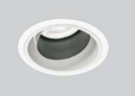 | Nos | . NEW ITEM | 11253 | 135036
 |  |  | Dimension: ∅=108mm, Depth=100mm. |  |  |  | . NEW ITEM | 11253 | 135036
 |  |  | Lamp: 19.8W LED,19°, Focusable ,3000K CRI=96+(R9≥40+) |  |  |  | . NEW ITEM | 11253 | 135036
 |  |  | Lumen Output : 1377lm |  |  |  | . NEW ITEM | 11253 | 135036
 |  |  | Control Gear: Remote LED Driver. Dali Dimmable. |  |  |  | . NEW ITEM | 11253 | 135036
 |  |  | Power Consumption: 19.8W |  |  |  | . NEW ITEM | 11253 | 135036
 |  |  | IP20 |  |  |  |  | 11253 | 135036
 |  | 17 | Ceiling Recessed LED Down Light |  |  |  |  | 13401 | 67005
 |  |  | Housing: Die cast aluminium | RDN5 |  | 5.00 | This is OK. | 13401 | 67005
  GERD8202WB-T
 |  |  | Dimension: ∅=108mm, Depth=133mm. |  |  | Nos | This is OK. | 13401 | 67005
 |  |  | Lamp: 28.5W LED, 32°, Fixed Optics, 3000K CRI=83+(R9≥40+) |  |  |  | This is OK. | 13401 | 67005
 |  |  | Lumen Output : 1597lm |  |  |  | This is OK. | 13401 | 67005
 |  |  | Control Gear: Remote LED Driver. Dali Dimmable. |  |  |  | This is OK. | 13401 | 67005
 |  |  | Power Consumption: 28.5W |  |  |  | This is OK. | 13401 | 67005
 |  |  | IP20 |  |  |  | This is OK. | 13401 | 67005
 |  | 18 | Surface Mounted LED Down Light. |  |  |  |  | 3908 | 54712
 |  |  | Housing: Die cast aluminium | SDN1 |  | 14.00 | OLD QTY 10 NOS. WE HAVE PROPOSED ALTERNATE ECONOMICAL OPTION IN Abby BRAND. | 3908 | 54712
  Abby Surface Down light 14W, 3000K
 |  |  | Dimension: ∅=152mm & H=38mm. |  | 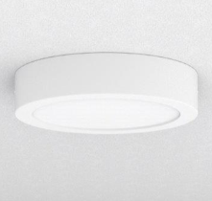 | Nos |  | 3908 | 54712
 |  |  | Lamp:15W LED, Flood Beam, Fixed, 3000K, CRI=85+(R9≥40+) |  |  |  |  | 3908 | 54712
 |  |  | Lumen Output : 1209lm |  |  |  |  | 3908 | 54712
 |  |  | Control Gear: LED Driver. Dali Dimmable. |  |  |  |  | 3908 | 54712
 |  |  | Power Consumption: 15W |  |  |  |  | 3908 | 54712
 |  |  | IP44 Required |  |  |  |  | 3908 | 54712
 |  | 19 | Ceiling Recessed LED Light, Fixed. | SDN2 | GERD8604W-T | 12.00 |  | 10345 | 124140
 |  |  | Housing: Die cast aluminium |  | 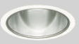 | Nos |  | 10345 | 124140
 |  |  | Dimension: ∅=108mm, Cutout∅=100 & Height=110mm. |  |  |  |  | 10345 | 124140
 |  |  | Lamp:19.3W LED, 31° Fixed, 3000K, CRI=85(R9≥40+) |  |  |  |  | 10345 | 124140
 |  |  | Lumen Output : 2014lm |  |  |  |  | 10345 | 124140
 |  |  | Control Gear: Remote LED Driver. Dali Dimmable. |  |  |  |  | 10345 | 124140
 |  |  | Power Consumption: 19.3W |  |  |  |  | 10345 | 124140
 |  |  | IP44 Required |  |  |  |  | 10345 | 124140
 |  | 20 | Spike Mounted LED Projector Light. |  | GERS6922H-T | 11.00 | OLD QTY 6 | 10819 | 119009
 |  |  | Housing: Alluminium | SPK1 |  | Nos | OLD QTY 6 | 10819 | 119009
  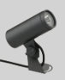
 |  |  | Dimension: ∅=61mm, Ht=141mm |  |  |  | OLD QTY 6 | 10819 | 119009
 |  |  | Lamp:10W LED,23º, 3000K CRI=80+ |  |  |  | OLD QTY 6 | 10819 | 119009
 |  |  | Lumen Output : 758lm |  |  |  | OLD QTY 6 | 10819 | 119009
 |  |  | Control Gear: Remote LED Driver. Non-Dimmable. |  |  |  | OLD QTY 6 | 10819 | 119009
 |  |  | Power Consumption: 10.1W |  |  |  | OLD QTY 6 | 10819 | 119009
 |  |  | IP65 |  |  |  | OLD QTY 6 | 7530 | 82830
 |  | 21 | Spike Mounted LED Projector Light. |  | GERS7306H-T +GRB898N | 11.00 | OLD QTY 6 | 7530 | 82830
 |  |  | Housing: Alluminium | SPK2 | 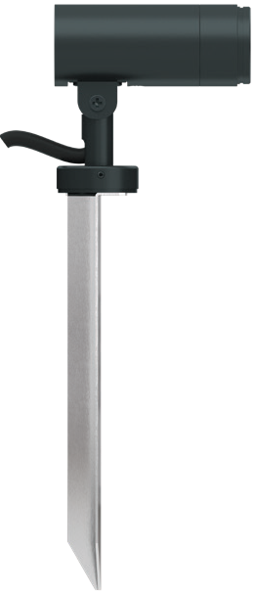  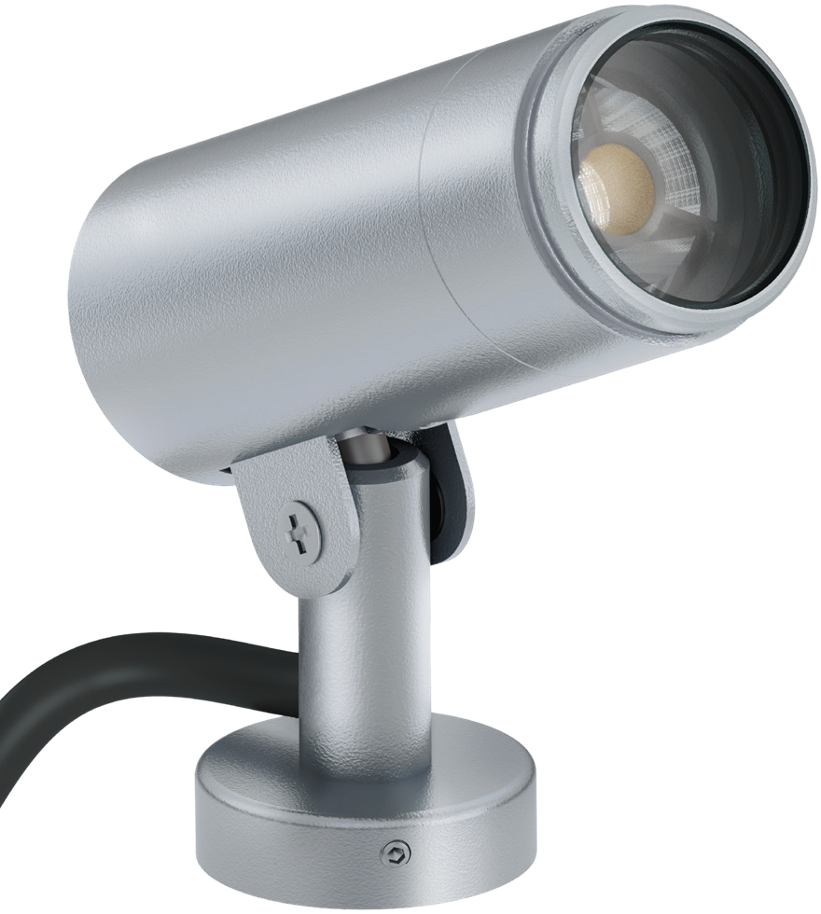 | nos | OLD QTY 6 | 7530 | 82830
 |  |  | Dimension: ∅=35mm, Ht=63mm |  |  |  | OLD QTY 6 | 7530 | 82830
 |  |  | Lamp:3W LED,45º, 3000K CRI=80+ |  |  |  | OLD QTY 6 | 7530 | 82830
 |  |  | Lumen Output : 230lm |  |  |  | OLD QTY 6 | 7530 | 82830
 |  |  | Control Gear: Remote LED Driver. Non-Dimmable. |  |  |  | OLD QTY 6 | 7530 | 82830
 |  |  | Power Consumption: 10.1W |  |  |  | OLD QTY 6 | 7530 | 82830
 |  |  | IP65 |  |  |  | OLD QTY 6 | 7530 | 82830
 |  | 22 | Underwater LED Up Lighter.
 |  |  | Housing: Stainless Steel | UWL3 |  |  | Regret
 |  |  | Dimension: TrimØ=81mm, Cut OutØ=79mm & Ht=100mm. |  |  |  | Regret
 |  |  | Lamp: 6W LED, 10°, 3000K, CRI=80+ |  |  |  | Regret
 |  |  | Lumen Output : 576lm |  |  |  | Regret
 |  |  | Control Gear: Remote LED Driver. Dali Dimmable. |  |  |  | Regret
 |  |  | Power Consumption: 6W |  |  |  | Regret
 |  |  | IP68 |  |  |  | Regret
 |  | 23 | Wall Mounted LED Light. |  | EWLR2-300-1030-K | 5.00 | OLD QTY 6 | 14811 | 74055
 |  |  | Housing: Die cast Aluminium | WML1 | 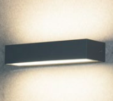 | Nos | OLD QTY 6 | 14811 | 74055
 |  |  | Dimension: ∅=300mm, Ht=57mm |  |  |  | OLD QTY 6 | 14811 | 74055
 |  |  | Lamp:9W LED,92°×75°, 3000K CRI=80+ |  |  |  | OLD QTY 6 | 14811 | 74055
 |  |  | Lumen Output : 836lm |  |  |  | OLD QTY 6 | 14811 | 74055
 |  |  | Control Gear: Remote LED Driver. Non-Dimmable. |  |  |  | OLD QTY 6 | 14811 | 74055
 |  |  | Power Consumption: 9W |  |  |  | OLD QTY 6 | 14811 | 74055
 |  |  | IP65 |  |  |  | OLD QTY 6 | 14811 | 74055
 |  | 24 | Wall Recessed LED Light. |  |  |  | OLD QTY 10 | 7378 | 81158
 |  |  | Housing: Die cast Aluminium | WRL1 | ELFR5-255-0630-K | 11.00 | OLD QTY 10 | 7378 | 81158
 |  |  | Dimension: ∅=255mm, Ht=67mm |  | 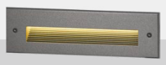 | Nos | OLD QTY 10 | 7378 | 81158
 |  |  | Lamp: 5.7W LED, 3000K CRI=80+ |  |  |  | OLD QTY 10 | 7378 | 81158
 |  |  | Lumen Output : CW=113 WW=104 |  |  |  | OLD QTY 10 | 7378 | 81158
 |  |  | Control Gear: Remote LED Driver. Non-Dimmable. |  |  |  | OLD QTY 10 | 7378 | 81158
 |  |  | Power Consumption: 5.7W |  |  |  | OLD QTY 10 | 7378 | 81158
 |  |  | IP65 |  |  |  | OLD QTY 10 | 7378 | 81158
 |  | 25 | Wall Recessed LED FootLight | WRL2 | ELFR2-72-0330-K | 21.00 |  | 5590 | 117390
 |  |  | Housing: Die cast Aluminium |  |  | Nos |  | 5590 | 117390
 |  |  | Dimension: ∅=72mm, Ht=75mm |  |  |  |  | 5590 | 117390
  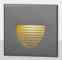
 |  |  | Lamp: 3.1W LED, 3000K CRI=80+ |  |  |  |  | 5590 | 117390
 |  |  | Lumen Output : CW=25 WW=22 |  |  |  |  | 5590 | 117390
 |  |  | Control Gear: Remote LED Driver. Non-Dimmable. |  |  |  |  | 5590 | 117390
 |  |  | Power Consumption: 3.1W |  |  |  |  | 5590 | 117390
 |  |  | IP65 |  |  |  |  | 5590 | 117390
 |  | 26 | Wall Recessed LED Light. | WRL3 | ELFR5-255-0630-K | 6.00 | NEW ITEM | 7378 | 44268
 |  |  | Housing: Die cast Aluminium |  |  | Nos | NEW ITEM | 7378 | 44268
 |  |  | Dimension: ∅=255mm, Ht=67mm |  |  |  | NEW ITEM | 7378 | 44268
 |  |  | Lamp: 5.7W LED, 3000K CRI=80+ |  |  |  | NEW ITEM | 7378 | 44268
 |  |  | Lumen Output : CW=113 WW=104 |  |  |  | NEW ITEM | 7378 | 44268
 |  |  | Control Gear: Remote LED Driver. Non-Dimmable. |  |  |  | NEW ITEM | 7378 | 44268
 |  |  | Power Consumption: 5.7W |  |  |  | NEW ITEM | 7378 | 44268
 |  |  | IP65 |  |  |  | NEW ITEM | 7378 | 44268
 |  |  |  |  |  |  |  | Total | 4,000,000
 |  |  |  |  |  |  |  | GST 18% | 720,000
 |  |  |  |  |  |  |  | Grand Total | 4,720,000

Underwater:

PROJECT : RIVER GLADE VILLAS |  | BILL OF QUANTITIES FOR RIVER GLADE VILLAS - Villa 03 |  |  | Date: 24 SEPT 2024
Notes : Included are luminaires suggested for - Interior Lighting for VILLA-03
Kindly Refer the detail specifications with this BOQ. If you Find any descripancies , please get it to our notice before placing final order.
Sr No | Specification Description |  | Symbol | Manufacturer |  | Total Quantity | Remarks
22 | Underwater LED Up Lighter. |  |  | PUK Lighting
 | Housing: Stainless Steel |  | UWL3 | 301004 |  | 2.00 | Black Finish Required
 | Dimension: TrimØ=81mm, Cut OutØ=79mm & Ht=100mm. |  |  |  |  | Nos
 | Lamp: 6W LED, 10°, 3000K, CRI=80+
 | Lumen Output : 576lm
 | Control Gear: Remote LED Driver. Dali Dimmable.
 | Power Consumption: 6W
 | IP68

DATE: 24 OCT 2024
 |  | ENDO ALTERNATES
 |  | Sr No | Specification Description | Symbol | Manufacturer | Total Quantity | Remarks/ L@W Comments | BEST PRICE | Total
 |  | 22 | Underwater LED Up Lighter. |  | PUK Lighting |  |  | 35890 | 71780
 |  |  | Housing: Stainless Steel | UWL3 | 301004 | 2.00 | Same brand quoted which is proposed by consultant | 35890 | 71780
 |  |  | Dimension: TrimØ=81mm, Cut OutØ=79mm & Ht=100mm. |  |  | nos | Same brand quoted which is proposed by consultant | 35890 | 71780
 |  |  | Lamp: 6W LED, 10°, 3000K, CRI=80+ |  |  |  | Same brand quoted which is proposed by consultant | 35890 | 71780
 |  |  | Lumen Output : 576lm |  |  |  | Same brand quoted which is proposed by consultant | 35890 | 71780
 |  |  | Control Gear: Remote LED Driver. Dali Dimmable. |  |  |  | Same brand quoted which is proposed by consultant | 35890 | 71780
 |  |  | Power Consumption: 6W |  |  |  | Same brand quoted which is proposed by consultant | 35890 | 71780
 |  |  | IP68 |  |  |  | Same brand quoted which is proposed by consultant | 35890 | 71780
 |  |  |  |  |  |  |  | Total | 71,780
 |  |  |  |  |  |  |  | GST 18% | 12,920
 |  |  |  |  |  |  |  | Grand Total | 84,700

Client scope:
Scaffolding wherever required to be provided.
Electrification wherever necessary to be provided.
Fabrication like poles etc. to be provided.
Fabricated poles if required to be provided.
Civil work if required.

Payment Terms
100% Advance

Company’s Bank Details
Bank Name: Central Bank of India
Account Number: 3167002097
Branch & IFS Code: Panaji & CBIN0280713

Terms & conditions apply.
Quotation valid for 10 days only.
If payment not received on time interest @ 15% will be levied per annum.
Any extra item if required to be charged as actual.
Warranty as per manufacturer not valid in case of surges, fluctuation, lightening etc.to be claimed directly with the
manufacturer without involving JP TECHATRONICS.
Solution done as per recommendation and request by client hence, JP TECHATRONICS or its employees should not be held responsible for any kind of malfunctioning of the system for any reasons.
Services like data backup, searching footage, port forwarding etc. to be charged as actuals.
Service calls post installation to be charged as actuals.

